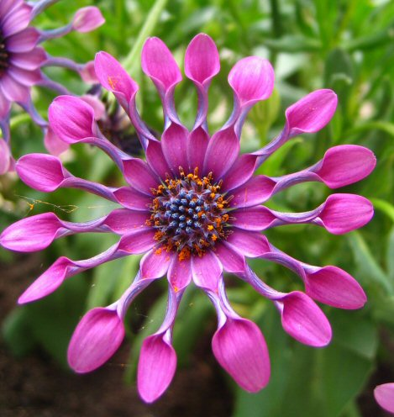 This is practice file 3 to be used with Lab 1.